Conformity
Assessment
Roadmap
Step-by-Step Guide for High-Risk AI Systems
Articles 40-49 EU AI Act

Version 1.0 | March 2026
Responsible AI Platform

1. Introduction
Before a high-risk AI system can be placed on the EU market or put into service, providers must demonstrate that it complies with the requirements of the EU AI Act through a conformity assessment procedure. This roadmap guides you through each step.

2. When is Conformity Assessment Required?
A conformity assessment is required when:
- You are a provider of a high-risk AI system (Annex III)
- Your AI system is a safety component of a product covered by Annex I legislation
- You make a substantial modification to an already-assessed high-risk AI system
- You are an importer or distributor who places the system under your own name/brand

3. Assessment Routes
Route | When It Applies | Procedure
Internal control (Annex VI) | Most Annex III high-risk AI systems | Self-assessment by the provider based on internal quality management
Third-party assessment (Annex VII) | Biometric identification systems (Annex III, point 1) | Assessment by a notified body
Product legislation | AI as safety component under Annex I (e.g., medical devices, machinery) | Follow existing conformity procedure of product legislation + AI Act requirements

4. Step-by-Step Roadmap

Step 1: Determine Your Role
- Confirm you are the provider (developer or entity placing on market)
- If you are deployer only: conformity assessment is not your obligation, but verify provider compliance
- If you substantially modify a system: you become a new provider (Article 25)

Step 2: Classify the AI System
- Determine if system falls under Annex III categories
- Check if system is safety component under Annex I product legislation
- Document classification rationale with article references
- Consider exception: AI systems under Annex III that do not pose significant risk to health, safety, or fundamental rights may be excluded if conditions in Article 6(3) are met

Step 3: Identify Applicable Standards
- Check for harmonized standards published in the Official Journal (Article 40)
- If no harmonized standards exist: follow common specifications adopted by Commission (Article 41)
- Document which standards or specifications your system complies with
- Compliance with harmonized standards creates presumption of conformity

Step 4: Implement Requirements
- Risk management system (Article 9)
- Data governance (Article 10)
- Technical documentation (Article 11, Annex IV)
- Record-keeping / logging (Article 12)
- Transparency and information to deployers (Article 13)
- Human oversight measures (Article 14)
- Accuracy, robustness, cybersecurity (Article 15)
- Quality management system (Article 17)

Step 5: Prepare Technical Documentation
- Complete Annex IV documentation requirements
- Use the Technical Documentation Checklist template
- Ensure documentation is kept up-to-date
- Documentation must be available to national authorities for 10 years

Step 6: Conduct the Assessment
- ROUTE A (Internal): Follow Annex VI procedure
Verify quality management system covers AI Act requirements
Verify technical documentation demonstrates compliance
Internal review and sign-off by authorized person

- ROUTE B (Third-party): Follow Annex VII procedure
Select a notified body (check EU NANDO database)
Submit application with technical documentation
Cooperate with notified body during assessment
Address any non-conformities identified

Step 7: Draw Up EU Declaration of Conformity
- Create declaration per Article 47 and Annex V
- Include: provider name, AI system identification, statement of compliance
- Reference standards and specifications used
- Sign and date the declaration
- Keep declaration for 10 years after system is placed on market

Step 8: Affix CE Marking
- Affix CE marking visibly, legibly, and indelibly (Article 48)
- If not possible on the system itself: affix on packaging or documentation
- CE marking indicates compliance with EU AI Act requirements

Step 9: Register in EU Database
- Register the AI system in the EU database per Article 49
- Provider registration includes system details and declaration of conformity
- Registration must be done before the system is placed on the market
- Keep registration information up-to-date

Step 10: Post-Market Monitoring
- Establish post-market monitoring system (Article 72)
- Proportionate to nature and risk level of the AI system
- Actively collect and review relevant data from deployers
- Evaluate continued compliance with requirements
- Report serious incidents within defined timelines (Article 62)
- Implement corrective actions when non-compliance is identified

5. Timeline Planning
Phase | Estimated Duration | Status | Target Date
1. Role & classification | 1-2 weeks | ☐
2. Standards identification | 1-2 weeks | ☐
3. Requirements implementation | 2-6 months | ☐
4. Technical documentation | 1-3 months | ☐
5. Internal assessment (or notified body) | 1-3 months | ☐
6. Declaration of conformity | 1 week | ☐
7. CE marking | 1 day | ☐
8. EU database registration | 1 week | ☐
9. Post-market monitoring setup | 1-2 months | ☐

6. Key Articles Reference
Article | Topic
Art. 6 | Classification of high-risk AI systems
Art. 9 | Risk management system
Art. 10 | Data and data governance
Art. 11 | Technical documentation
Art. 12 | Record-keeping
Art. 13 | Transparency and provision of information
Art. 14 | Human oversight
Art. 15 | Accuracy, robustness, cybersecurity
Art. 17 | Quality management system
Art. 40 | Harmonised standards
Art. 43 | Conformity assessment
Art. 47 | EU declaration of conformity
Art. 48 | CE marking
Art. 49 | Registration
Art. 62 | Reporting of serious incidents
Art. 72 | Post-market monitoring
Annex IV | Technical documentation requirements
Annex V | EU declaration of conformity
Annex VI | Internal control procedure
Annex VII | Conformity assessment with notified body

7. Progress Tracker
AI System Name:
________________________________________________________________________________
Provider:
________________________________________________________________________________
Assessment Route:
________________________________________________________________________________
Project Lead:
________________________________________________________________________________
Start Date:
________________________________________________________________________________
Target Completion:
________________________________________________________________________________
Template provided by Responsible AI Platform | www.aiactblog.nl

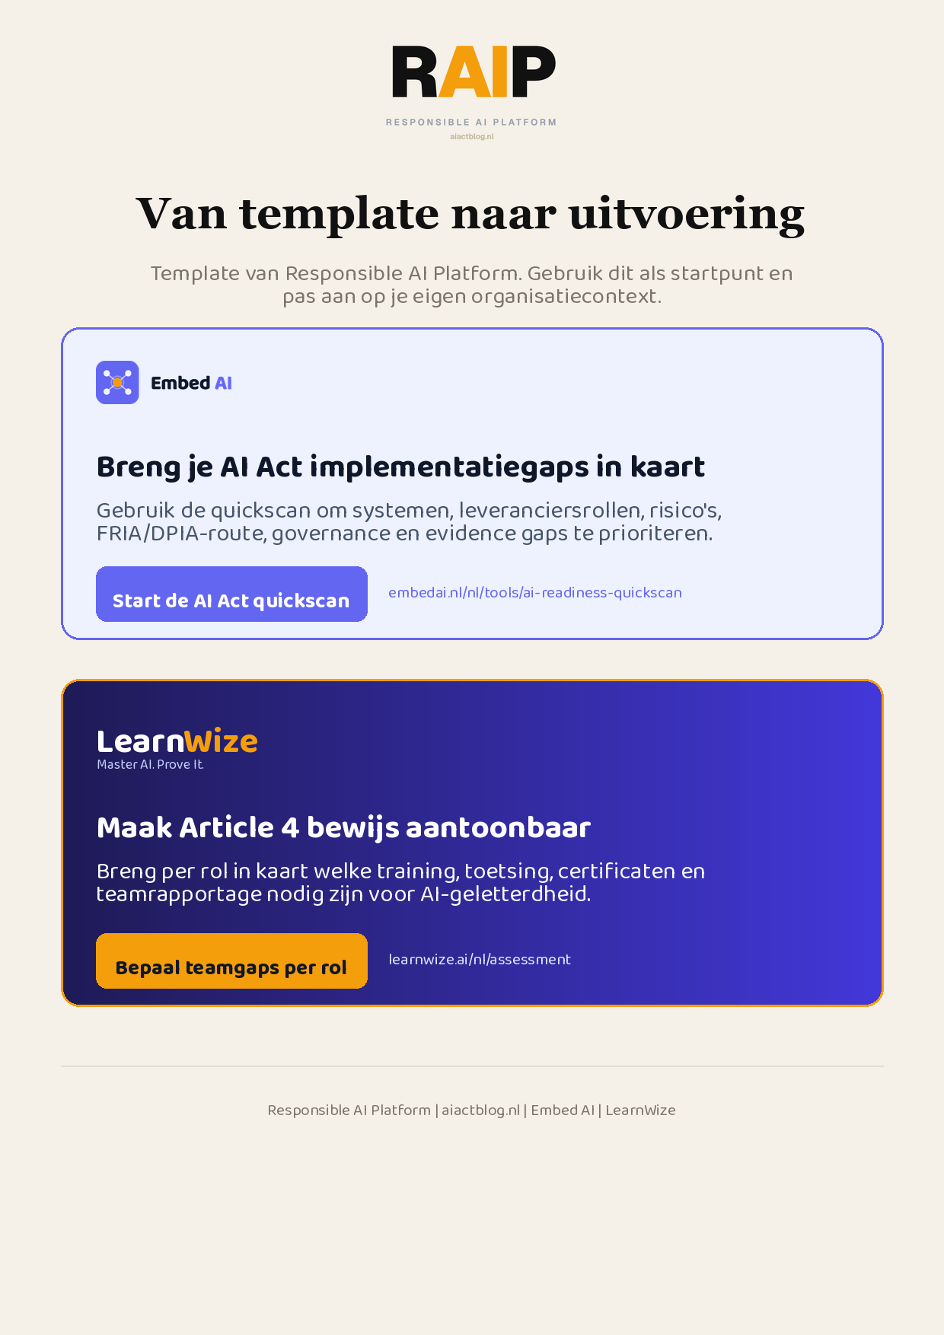
Klikbare links: Start de AI Act quickscan | Bepaal teamgaps per rol
AIACT_BRANDED_CTA_V2

