AI Transparency
Notice
Article 50 EU AI Act Compliance
User Notification Templates

Version 1.0 | March 2026
Responsible AI Platform

1. Purpose
Article 50 of the EU AI Act (applicable from 2 August 2026) imposes transparency obligations on providers and deployers of certain AI systems. This template provides ready-to-use notification texts for different scenarios.

2. When Transparency Notices Are Required
Scenario | Article | Who Must Notify | Deadline
AI system interacting with persons | 50(1) | Provider | 2 August 2026
Emotion recognition system | 50(3) | Deployer | 2 August 2026
Biometric categorization system | 50(3) | Deployer | 2 August 2026
AI-generated/manipulated content (deepfakes) | 50(4) | Provider + Deployer | 2 August 2026
AI-generated text published for public information | 50(4) | Provider + Deployer | 2 August 2026

3. Template Notices

3.1 Chatbot / Virtual Assistant Notice
Use when deploying a chatbot or virtual assistant that interacts with persons.
AI Disclosure: You are interacting with an artificial intelligence system. This [chatbot/virtual assistant] is powered by AI technology. While it aims to provide helpful responses, it may not always be accurate. A human agent is available upon request. [Organization Name] deploys this AI system in accordance with the EU AI Act.

3.2 AI-Generated Content Notice
Use when publishing AI-generated or AI-assisted text, images, audio, or video.
This content was [generated/assisted] by artificial intelligence. It has been reviewed by [Organization Name] for accuracy. AI-generated elements include: [specify: text/images/data analysis]. In compliance with Article 50 of the EU AI Act, this disclosure is provided to ensure transparency.

3.3 Emotion Recognition System Notice
Use when deploying AI that detects emotions or intentions.
Notice: This system uses AI-based emotion recognition technology. [Brief description of what is being analyzed, e.g., 'facial expressions during the interview process']. The system processes [type of data] to [purpose]. You have the right to object to this processing. For questions, contact: [contact details]. Processing is carried out in accordance with Article 50(3) of the EU AI Act.

3.4 Biometric Categorization Notice
Notice: This area uses an AI-based biometric categorization system. The system [brief description of categorization, e.g., 'estimates age range for age verification purposes']. No biometric data is stored beyond the immediate processing. For questions about this system, contact: [contact details]. This notice is provided per Article 50(3) of the EU AI Act.

3.5 Deepfake / Synthetic Media Notice
AI-Generated Content: This [image/video/audio] has been artificially generated or manipulated using AI technology. It does not represent real events or real statements by depicted individuals. Created using [tool/model name]. Published by [Organization Name] in compliance with Article 50(4) of the EU AI Act.

3.6 AI-Assisted Decision Notice
This [decision/recommendation/assessment] was supported by an artificial intelligence system. The AI system analyzed [brief description of inputs] to generate [brief description of output]. The final decision was made by [human role/name]. You have the right to request explanation of this decision and to contest it. Contact: [details].

4. Implementation Checklist
☐ Inventory all AI systems requiring transparency notices
☐ Select appropriate notice template(s) for each system
☐ Customize template text with organization-specific details
☐ Legal review of customized notices
☐ Determine placement: before interaction, on-screen, in documentation
☐ Implement technical labeling/watermarking for AI-generated content
☐ Train customer-facing staff on transparency requirements
☐ Establish process for updating notices when systems change
☐ Document compliance evidence for regulatory audit

5. Technical Labeling Requirements
For AI-generated content (Article 50(2)), providers must ensure outputs are marked in a machine-readable format and detectable as artificially generated or manipulated.
Content Type | Labeling Method | Standard
Images | C2PA metadata, invisible watermark | ISO/IEC (pending)
Video | C2PA metadata, frame-level watermark | ISO/IEC (pending)
Audio | Audio watermark, metadata | ISO/IEC (pending)
Text | Metadata, disclosure label | Best practice (evolving)

Template provided by Responsible AI Platform | www.aiactblog.nl

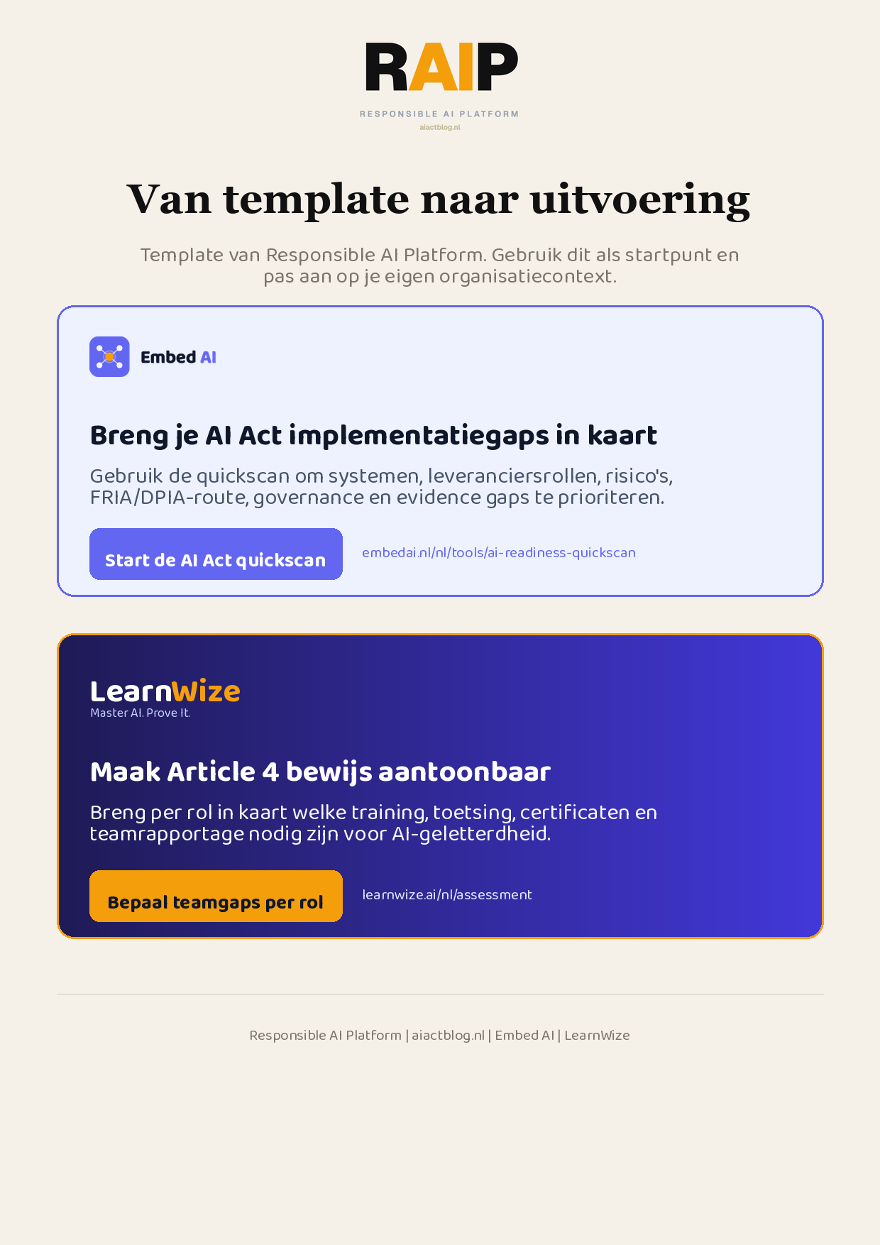
Klikbare links: Start de AI Act quickscan | Bepaal teamgaps per rol
AIACT_BRANDED_CTA_V2

