AI Training
Records
Article 4 EU AI Act Compliance Evidence
Employee Training Documentation

Version 1.0 | March 2026
Responsible AI Platform

1. Purpose
This template helps organizations document AI literacy training records as required by Article 4 of the EU AI Act. Maintaining accurate records demonstrates compliance and supports regulatory audits.

2. Organization Training Overview
Field | Value
Organization Name
Reporting Period
Total Employees
Employees Requiring AI Training
Training Completion Rate
Responsible Officer

3. Individual Training Records
Complete one record per employee. Keep records for the duration of employment plus 5 years.

Employee 1
Field | Value
Full Name
Employee ID
Department
Role / Function
Required Competency Level | ☐ Awareness ☐ Practitioner ☐ Expert
Training Module(s) Completed
Completion Date
Assessment Score
Pass / Fail | ☐ Pass ☐ Fail ☐ Pending
Certificate Issued | ☐ Yes ☐ No
Next Renewal Date
Trainer / Provider
Notes

Employee 2
Field | Value
Full Name
Employee ID
Department
Role / Function
Required Competency Level | ☐ Awareness ☐ Practitioner ☐ Expert
Training Module(s) Completed
Completion Date
Assessment Score
Pass / Fail | ☐ Pass ☐ Fail ☐ Pending
Certificate Issued | ☐ Yes ☐ No
Next Renewal Date
Trainer / Provider
Notes

Employee 3
Field | Value
Full Name
Employee ID
Department
Role / Function
Required Competency Level | ☐ Awareness ☐ Practitioner ☐ Expert
Training Module(s) Completed
Completion Date
Assessment Score
Pass / Fail | ☐ Pass ☐ Fail ☐ Pending
Certificate Issued | ☐ Yes ☐ No
Next Renewal Date
Trainer / Provider
Notes

Employee 4
Field | Value
Full Name
Employee ID
Department
Role / Function
Required Competency Level | ☐ Awareness ☐ Practitioner ☐ Expert
Training Module(s) Completed
Completion Date
Assessment Score
Pass / Fail | ☐ Pass ☐ Fail ☐ Pending
Certificate Issued | ☐ Yes ☐ No
Next Renewal Date
Trainer / Provider
Notes

Employee 5
Field | Value
Full Name
Employee ID
Department
Role / Function
Required Competency Level | ☐ Awareness ☐ Practitioner ☐ Expert
Training Module(s) Completed
Completion Date
Assessment Score
Pass / Fail | ☐ Pass ☐ Fail ☐ Pending
Certificate Issued | ☐ Yes ☐ No
Next Renewal Date
Trainer / Provider
Notes

4. Training Summary by Department
Department | Total Staff | Trained | % Complete | Avg Score | Next Deadline
TOTAL

5. Non-Compliance Register
Track employees who have not completed required training within deadlines.
Name | Department | Required Level | Deadline | Status | Action Taken

6. Audit Trail
Date | Action | Performed By | Notes
 | Training records created
 | Quarterly review completed
 | Annual audit completed

Template provided by Responsible AI Platform | www.aiactblog.nl

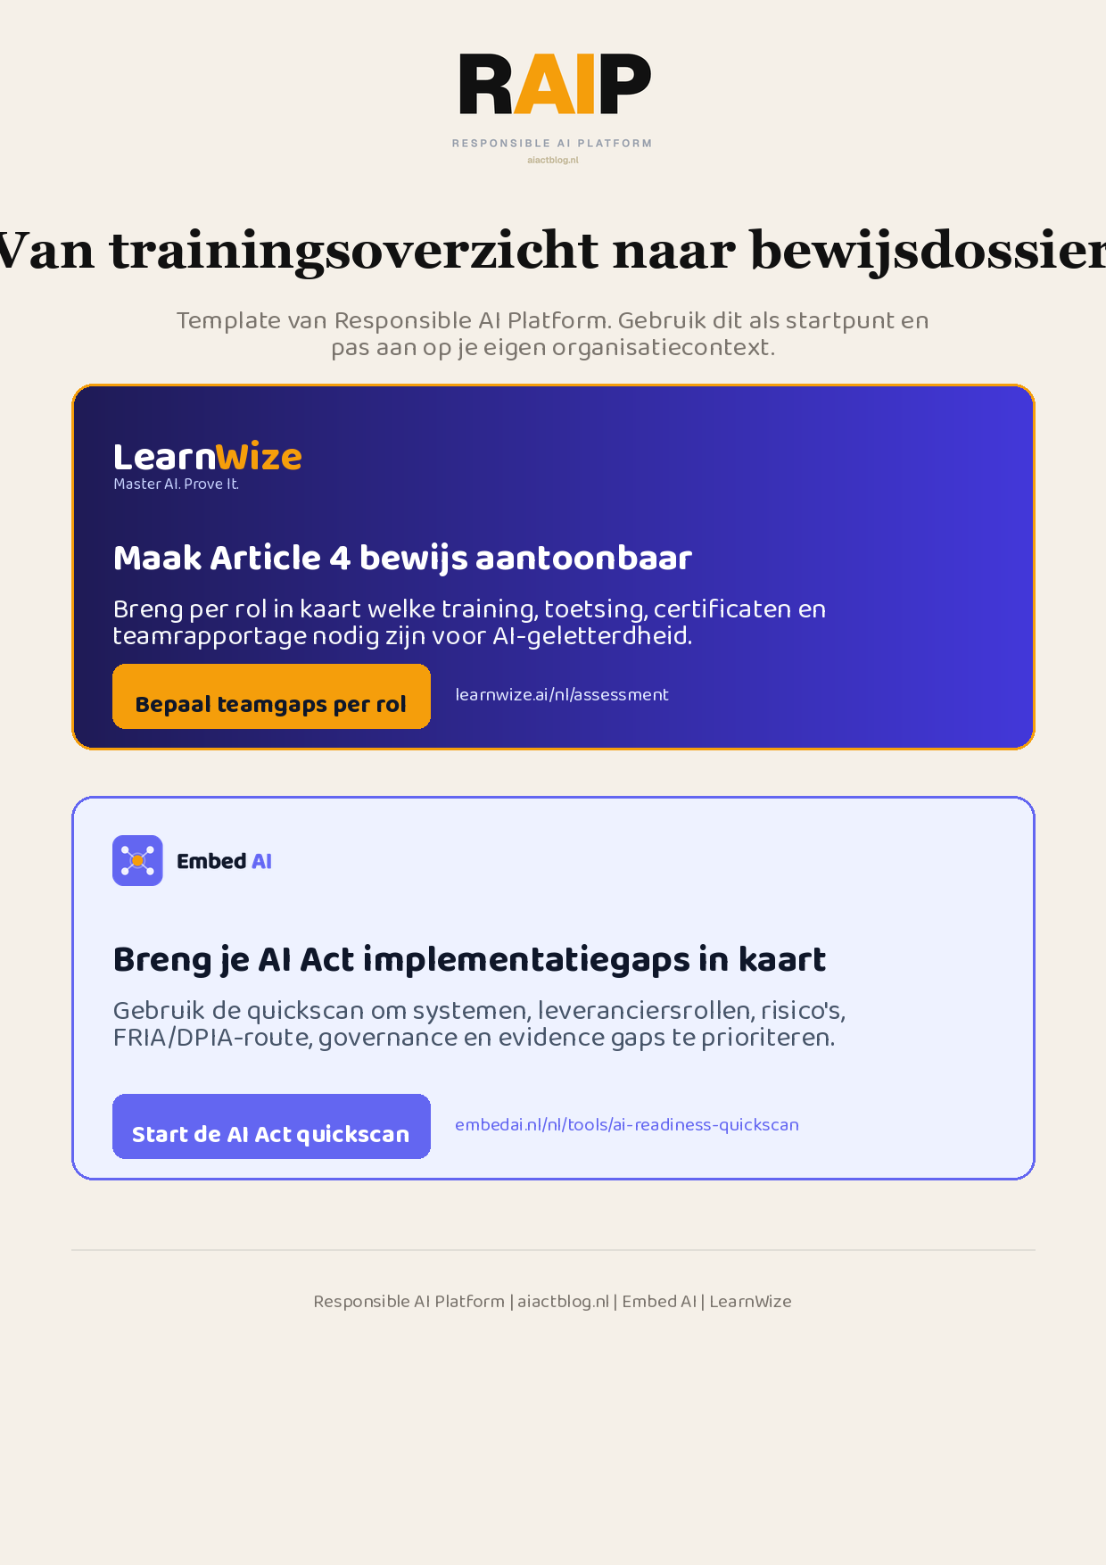
Klikbare links: Bepaal teamgaps per rol | Start de AI Act quickscan
AIACT_BRANDED_CTA_V2

