[Organization Name]
AI Policy
Organizational AI Policy — EU AI Act Compliance
Version 1.0 | [Date] | Confidential

Table of Contents
[Insert Table of Contents — In Word: References > Table of Contents]

1. Purpose & Scope
✏️ Define the purpose, scope, and applicability of this AI policy within your organization.
This policy establishes the principles, governance structure, and operational requirements for the development, procurement, deployment, and use of Artificial Intelligence (AI) systems within [Organization Name]. It applies to all employees, contractors, and third parties who develop, procure, deploy, or interact with AI systems on behalf of the organization.
The policy aims to ensure compliance with Regulation (EU) 2024/1689 (the EU AI Act) and aligns with the organization's values of responsible innovation, transparency, and respect for fundamental rights.

2. Definitions
✏️ Customize definitions to match your organization's terminology and the AI Act definitions (Article 3).
• AI System: A machine-based system designed to operate with varying levels of autonomy, that may exhibit adaptiveness after deployment and that, for explicit or implicit objectives, infers from the input it receives how to generate outputs such as predictions, content, recommendations, or decisions that can influence physical or virtual environments (Art. 3(1)).
• Provider: A natural or legal person that develops an AI system or has an AI system developed and places it on the market or puts it into service under its own name or trademark.
• Deployer: A natural or legal person that uses an AI system under its authority.
• High-Risk AI System: An AI system referred to in Article 6(1) or (2) of the AI Act.
• AI Literacy: Skills, knowledge, and understanding that allow providers, deployers, and affected persons to make informed decisions regarding AI systems (Art. 3(56)).

3. AI Governance Structure
✏️ Describe your organization's AI governance structure, including committees, reporting lines, and decision-making authority.
The AI governance structure consists of:
• AI Governance Board: Chaired by [C-level executive], responsible for strategic AI decisions, policy approval, and oversight.
• AI Officer: Appointed by the Board, responsible for day-to-day AI governance, compliance monitoring, and reporting.
• AI Ethics Committee: Advisory body reviewing ethical implications of AI deployments.
• Departmental AI Coordinators: Responsible for AI inventory and compliance within their department.
Reporting: The AI Officer reports quarterly to the Governance Board and annually to the Executive Board.

4. Roles & Responsibilities
✏️ Map roles to specific AI Act obligations. Reference the RACI matrix template for detailed assignments.
• Executive Board: Ultimate accountability for AI compliance; approves AI policy and risk appetite.
• AI Officer: Manages AI register, coordinates assessments, liaises with authorities.
• Data Protection Officer (DPO): Ensures alignment between AI Act and GDPR obligations.
• CISO: Oversees cybersecurity requirements for AI systems (Art. 15).
• Legal Department: Reviews AI contracts, licensing, and regulatory obligations.
• Business Owners: Responsible for AI systems within their domain; conduct initial risk classification.
• IT/Development Teams: Implement technical requirements (logging, testing, documentation).

5. AI Risk Classification
✏️ Describe the process for classifying AI systems according to the risk-based framework of the AI Act.
All AI systems must be classified before deployment using the following framework:
1. Unacceptable Risk (Prohibited — Art. 5): Systems that are banned outright.
2. High Risk (Art. 6 + Annex III): Systems subject to strict compliance requirements.
3. Limited Risk (Art. 50): Systems with transparency obligations.
4. Minimal Risk: Systems with no specific obligations beyond this policy.
Classification Process:
a) Complete the AI Risk Classification Checklist for each system.
b) Submit classification to the AI Officer for review.
c) High-risk classifications require Governance Board approval.
d) Re-classify when systems are substantially modified.

6. Prohibited AI Practices
✏️ List the prohibited practices from Article 5 and describe how your organization ensures compliance.
The following AI practices are strictly prohibited within [Organization Name]:
• Subliminal, manipulative, or deceptive techniques that distort behavior causing significant harm.
• Exploitation of vulnerabilities of specific groups (age, disability, social/economic situation).
• Social scoring by public authorities leading to detrimental treatment.
• Real-time remote biometric identification in publicly accessible spaces for law enforcement (with narrow exceptions).
• Untargeted scraping of facial images from the internet or CCTV for facial recognition databases.
• Emotion recognition in workplace and educational settings (with narrow exceptions).
• Biometric categorization inferring sensitive attributes (race, political opinions, etc.).
All employees must report suspected prohibited AI use immediately to the AI Officer.

7. High-Risk AI Requirements
✏️ Describe the requirements that apply to high-risk AI systems within your organization (Articles 8-15).
High-risk AI systems must comply with:
• Risk Management System (Art. 9): Continuous risk identification, analysis, and mitigation.
• Data Governance (Art. 10): Training, validation, and testing datasets meeting quality criteria.
• Technical Documentation (Art. 11): Comprehensive documentation per Annex IV.
• Record-Keeping (Art. 12): Automatic logging of events during operation.
• Transparency (Art. 13): Clear instructions for use provided to deployers.
• Human Oversight (Art. 14): Effective human oversight measures.
• Accuracy, Robustness & Cybersecurity (Art. 15): Appropriate levels maintained throughout lifecycle.

8. Data Governance for AI
✏️ Define data governance requirements specific to AI systems, including training data, quality, and bias monitoring.
AI data governance requirements:
• Training data must be relevant, representative, and as free of errors as possible.
• Data quality metrics must be established and monitored for each AI system.
• Bias detection and mitigation processes must be implemented.
• Data provenance and lineage must be documented.
• Special category data processing must comply with GDPR Article 9.
• Data retention periods for AI training data must be defined and enforced.
• Access controls must restrict data access to authorized personnel only.

9. Transparency & Explainability
✏️ Define transparency requirements for different AI risk categories and stakeholder groups.
Transparency obligations:
• All AI-generated content must be clearly marked as such where required.
• Persons interacting with AI systems must be informed they are doing so (Art. 50).
• Deployers of emotion recognition or biometric systems must inform affected persons.
• AI-generated or manipulated content (deepfakes) must be labeled.
• High-risk systems must provide sufficient transparency for deployers to interpret outputs.
Explainability:
• High-risk AI decisions affecting individuals must be explainable in understandable terms.
• Technical explanations must be available for auditors and supervisory authorities.

10. Human Oversight
✏️ Define human oversight mechanisms for AI systems, especially high-risk systems.
Human oversight measures include:
• Human-in-the-loop: A human can intervene in every decision cycle of the AI system.
• Human-on-the-loop: A human monitors the AI system and can intervene during operation.
• Human-in-command: A human oversees the overall AI system and can override or shut down.
For high-risk systems:
• Designated human overseers must be identified and trained.
• Override and emergency stop capabilities must be implemented.
• Overseers must have authority to disregard, override, or reverse AI outputs.
• Regular competency assessments for overseers are mandatory.

11. AI Literacy & Training
✏️ Describe the AI literacy program required under Article 4, including target groups and training content.
In accordance with Article 4, [Organization Name] ensures adequate AI literacy for:
• All staff: Basic AI awareness training (annual).
• AI system users: Role-specific training on systems they operate.
• Management: Strategic AI governance training.
• Technical staff: Advanced training on AI development, testing, and compliance.
• AI Officer & compliance team: Specialized regulatory training.
Training covers: AI fundamentals, EU AI Act obligations, risk identification, ethical considerations, and hands-on tool usage. Completion is tracked and reported.

12. Procurement & Third-Party AI
✏️ Define requirements for procuring AI systems from third parties and managing vendor compliance.
When procuring AI from third parties:
• Vendors must provide documentation per Art. 13 (instructions for use).
• Conduct due diligence on provider compliance (CE marking for high-risk).
• Include AI Act compliance clauses in contracts.
• Verify registration in the EU AI database where applicable.
• Assess whether the organization becomes a provider through substantial modification.
• Establish ongoing monitoring and audit rights.
• Maintain vendor AI compliance scorecards.

13. Monitoring & Audit
✏️ Define ongoing monitoring and audit processes for AI systems.
Monitoring framework:
• Continuous performance monitoring for all deployed AI systems.
• Quarterly compliance reviews for high-risk systems.
• Annual comprehensive AI audit covering all systems.
• Post-market monitoring as required for providers (Art. 72).
• Incident tracking and trend analysis.
Audit scope includes: accuracy/performance, bias/fairness, data quality, security, compliance with this policy, and regulatory requirements. Audit findings are reported to the Governance Board.

14. Incident Management
✏️ Define the process for managing AI-related incidents, including serious incidents per Article 73.
AI incident categories:
• Critical: Serious incident per Art. 73 (death, serious damage to health, property, environment, or fundamental rights). Report to national authority within prescribed timelines.
• High: Significant performance degradation, bias detected, data breach involving AI.
• Medium: Minor performance issues, user complaints, near-misses.
• Low: Cosmetic issues, minor bugs.
Process: Detect → Contain → Investigate → Remediate → Report → Learn.
All incidents must be logged in the AI incident register. Serious incidents must be reported to the relevant market surveillance authority.

15. Review & Update Procedure
✏️ Define how and when this policy is reviewed and updated.
This policy shall be:
• Reviewed annually by the AI Officer and Governance Board.
• Updated whenever significant regulatory changes occur.
• Updated when new AI systems substantially change the risk profile.
• Communicated to all relevant stakeholders after each update.
Version control:
• All versions are retained for a minimum of 10 years.
• Changes are tracked in the version history table below.
Version History:
| Version | Date | Author | Changes |
| 1.0 | [Date] | [Author] | Initial version |

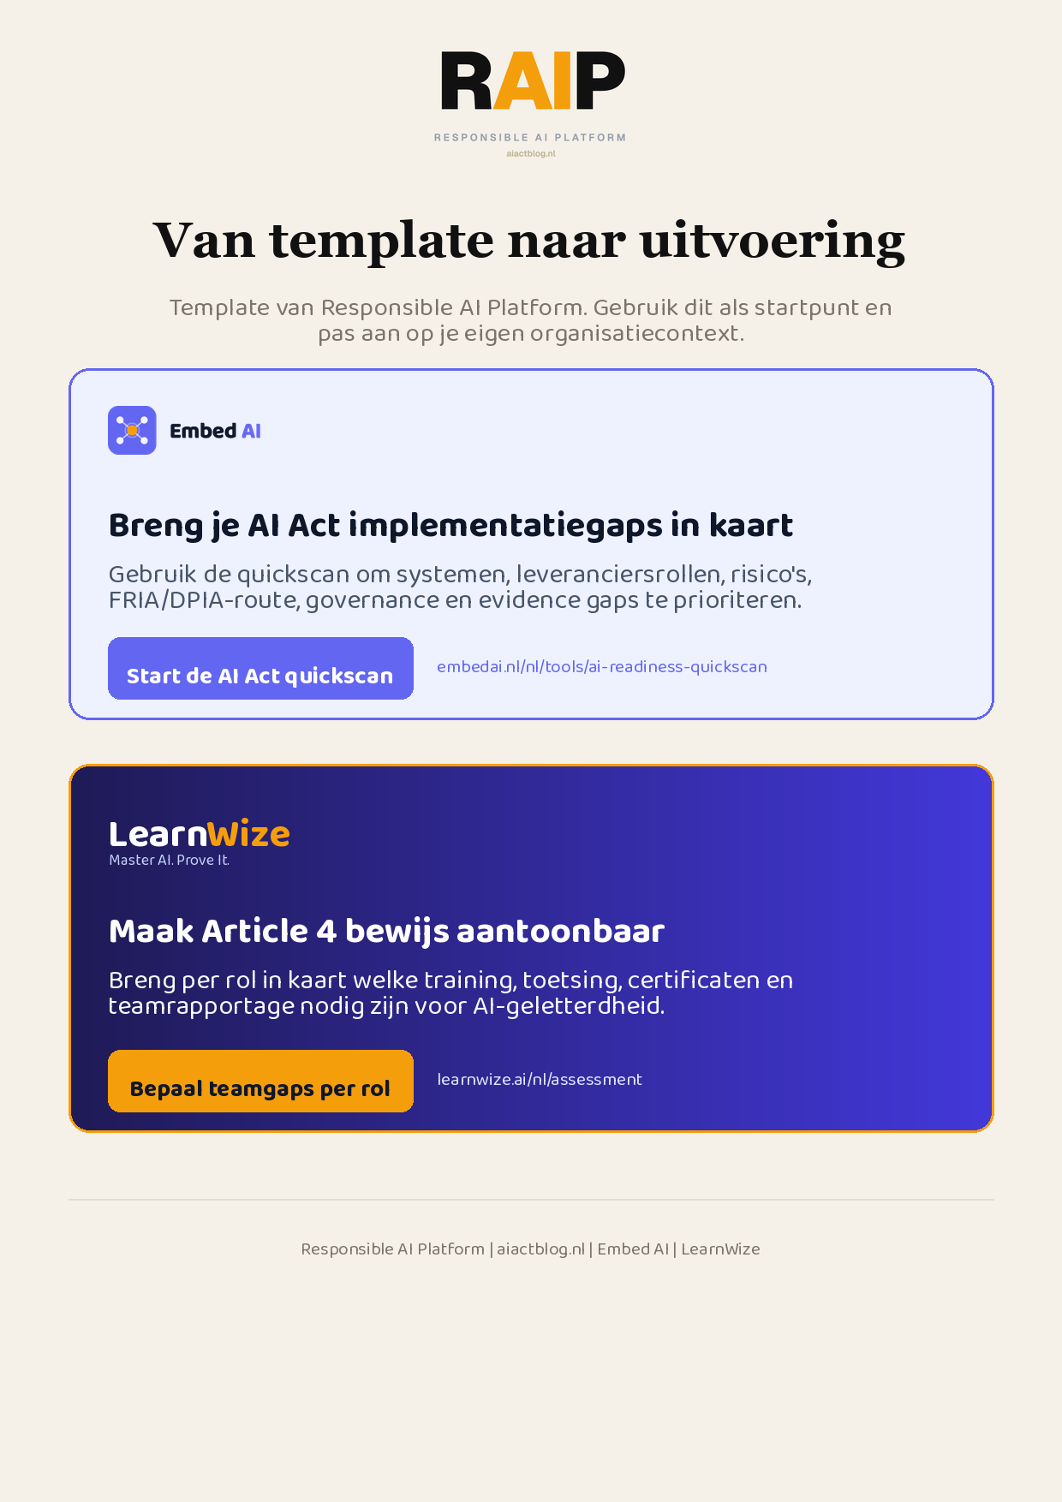
Klikbare links: Start de AI Act quickscan | Bepaal teamgaps per rol
AIACT_BRANDED_CTA_V2

