AI Literacy Policy
Article 4 EU AI Act Compliance
Training Framework & Competency Levels

Version 1.0 | March 2026
Responsible AI Platform

1. Purpose
Article 4 of the EU AI Act requires that providers and deployers of AI systems ensure their staff and other persons dealing with the operation and use of AI systems on their behalf have a sufficient level of AI literacy. This policy establishes the training framework, competency levels, and documentation requirements.

2. Scope
This policy applies to:
- All employees who interact with, develop, deploy, or make decisions about AI systems
- Management responsible for AI governance decisions
- Contractors and temporary staff working with AI systems
- Third-party personnel operating AI systems on behalf of the organization

3. Competency Levels
The organization defines three competency levels aligned with Article 4 requirements:
Level | Target Group | Competencies Required | Assessment
Awareness | All employees | Understanding of AI basics, recognizing AI outputs, awareness of risks, responsible use principles | Online quiz (80% pass rate)
Practitioner | AI users, managers, procurement | Risk classification, compliance basics, FRIA awareness, vendor assessment, bias recognition | Case study + quiz (80% pass rate)
Expert | AI developers, data scientists, AI officer | Technical compliance, documentation requirements, risk management systems, conformity assessment | Portfolio + practical exam

4. Training Curriculum

4.1 Awareness Level
Module | Duration | Topics
What is AI? | 30 min | Definition, types of AI, how AI systems work, limitations
AI in the Workplace | 30 min | Common AI tools, ChatGPT/Copilot usage, when AI is appropriate
AI Risks | 30 min | Bias, hallucinations, privacy risks, security concerns, over-reliance
EU AI Act Basics | 30 min | Why regulation exists, risk levels, your role and responsibilities
Responsible AI Use | 30 min | Acceptable use guidelines, reporting concerns, ethical considerations

4.2 Practitioner Level
Module | Duration | Topics
EU AI Act Deep Dive | 2 hours | Risk classification, obligations per role, timelines, enforcement
AI Risk Assessment | 1.5 hours | How to classify AI systems, prohibited practices, Annex III
FRIA and Compliance | 1.5 hours | Fundamental rights impact, data protection, documentation
AI Vendor Management | 1 hour | Due diligence, contract clauses, ongoing monitoring
Sector-Specific AI | 1 hour | Relevant regulations and use cases for your sector

4.3 Expert Level
Module | Duration | Topics
Technical Compliance | 3 hours | Annex IV documentation, risk management system (Art. 9), data governance (Art. 10)
Conformity Assessment | 2 hours | Self-assessment vs third-party, CE marking, EU database registration
AI Incident Management | 2 hours | Incident classification, root cause analysis, regulatory reporting (Art. 62)
Advanced Bias & Fairness | 2 hours | Statistical testing, disparate impact, mitigation strategies

5. Training Schedule
Event | Frequency | Target | Method
Onboarding training | At hire | All new employees | E-learning + quiz
Annual refresher | Yearly | All employees | E-learning (updated content)
Practitioner certification | Yearly | AI users & managers | Workshop + assessment
Expert certification | Yearly | AI team members | Training + practical exam
Regulatory updates | As needed | Governance Board + AI team | Briefing session
Incident response drill | Bi-annually | AI team + management | Tabletop exercise

6. Documentation and Records
The following records must be maintained for compliance evidence:
☐ Training completion records per employee (name, date, level, score)
☐ Training materials and curriculum versions
☐ Assessment results and certification status
☐ Attendance records for workshops and briefings
☐ Training needs analysis (annual)
☐ Budget allocation and spending records

7. Compliance Monitoring
KPI | Target | Measurement
Training completion rate | 95% within 3 months of deadline | LMS tracking
Assessment pass rate | 80% minimum | Quiz/exam scores
Time to onboard | Within 30 days of start date | HR records
Satisfaction score | 4.0+ / 5.0 | Post-training survey
Incident reduction | Year-over-year improvement | Incident reports

8. Roles and Responsibilities
Role | Responsibility
AI Officer | Oversee training program, ensure curriculum is current, report to board
HR Department | Administer training, track completion, onboarding integration
Department Heads | Ensure team compliance, identify additional training needs
Employees | Complete required training on time, apply learnings
External Trainers | Deliver specialized content, maintain expertise

9. Review and Updates
This policy is reviewed annually or when significant regulatory changes occur. The AI Officer is responsible for initiating reviews and proposing updates to the AI Governance Board.
Template provided by Responsible AI Platform | www.aiactblog.nl

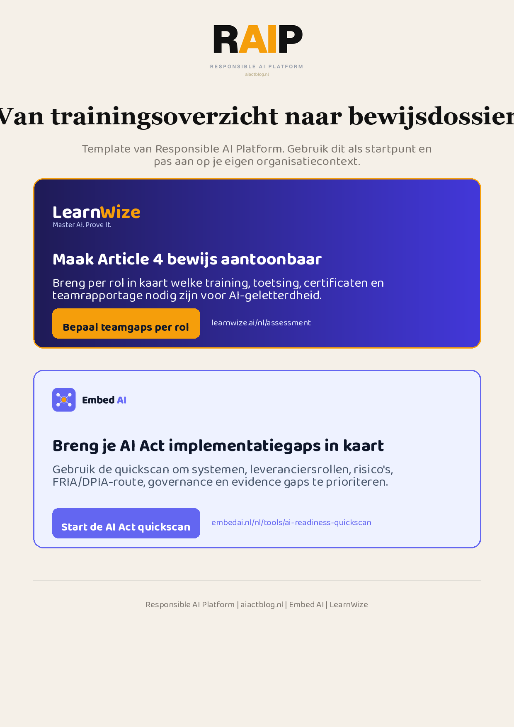
Klikbare links: Bepaal teamgaps per rol | Start de AI Act quickscan
AIACT_BRANDED_CTA_V2

