AI Incident
Response Plan
Article 62 EU AI Act Compliance
Incident Classification, Response & Reporting

Version 1.0 | March 2026
Responsible AI Platform

1. Purpose
This plan establishes the procedures for identifying, classifying, responding to, and reporting AI-related incidents. Article 62 of the EU AI Act requires providers of high-risk AI systems to report serious incidents to market surveillance authorities.

2. Scope
This plan covers:
- All AI systems operated by or on behalf of the organization
- Incidents involving AI system malfunction, bias, harm, or non-compliance
- Near-misses that could have resulted in harm
- Complaints from affected persons regarding AI systems

3. Incident Classification
Severity | Definition | Response Time | Reporting
Critical | Death, serious health damage, serious fundamental rights violation, or widespread harm caused by AI system | Immediate (within 1 hour) | Market surveillance authority within 15 days (Art. 62). If imminent risk: immediately.
High | Significant harm to individuals, major bias discovered, data breach via AI system | Within 4 hours | Internal AI Governance Board within 24h. Evaluate regulatory reporting.
Medium | Limited harm, performance degradation, minor bias detected, user complaints | Within 24 hours | AI Officer within 48h. Document and track.
Low | Minor anomaly, cosmetic issues, single user complaint, near-miss | Within 72 hours | Log in incident register. Review at next governance meeting.

4. Response Procedure

Phase 1: Detection & Triage (0-2 hours)
☐ Incident detected (monitoring alert / user report / internal discovery)
☐ Initial assessment: classify severity level
☐ Assign Incident Lead from AI Incident Response Team
☐ For Critical/High: immediately notify AI Officer and management
☐ Document: what happened, when, which AI system, who is affected

Phase 2: Containment (2-4 hours for Critical)
☐ Activate human oversight to prevent further harm
☐ If necessary: disable or restrict the AI system
☐ Preserve logs and evidence for investigation
☐ Notify affected persons if immediate risk exists
☐ Brief AI Governance Board (Critical/High severity)

Phase 3: Investigation (24-72 hours)
☐ Conduct root cause analysis
☐ Review AI system logs and monitoring data
☐ Assess full scope of impact (persons affected, harm caused)
☐ Identify whether incident constitutes a serious incident under Art. 62
☐ Document findings in Incident Investigation Report

Phase 4: Resolution (Varies)
☐ Implement corrective actions to address root cause
☐ Test and validate the fix before re-deploying
☐ Update risk assessment and technical documentation
☐ Communicate resolution to affected persons
☐ Update AI register entry for the affected system

Phase 5: Reporting & Review (Within 15 days for serious incidents)
☐ For serious incidents: file report with market surveillance authority (Art. 62)
☐ Complete internal Incident Report
☐ Conduct lessons learned session with team
☐ Update incident response plan if needed
☐ Share anonymized learnings with organization

5. Incident Report Template
Incident ID:
________________________________________________________________________________
Date/Time of Incident:
________________________________________________________________________________
Date/Time of Detection:
________________________________________________________________________________
AI System Name & Version:
________________________________________________________________________________
Severity Classification:
________________________________________________________________________________
Incident Lead:
________________________________________________________________________________
Description of Incident:
________________________________________________________________________________
________________________________________________________________________________
________________________________________________________________________________
Persons/Groups Affected:
________________________________________________________________________________
________________________________________________________________________________
Harm Caused or Potential Harm:
________________________________________________________________________________
________________________________________________________________________________
Root Cause:
________________________________________________________________________________
________________________________________________________________________________
Corrective Actions Taken:
________________________________________________________________________________
________________________________________________________________________________
Preventive Measures:
________________________________________________________________________________
________________________________________________________________________________
Regulatory Reporting:
________________________________________________________________________________
Lessons Learned:
________________________________________________________________________________
________________________________________________________________________________

6. Incident Response Team
Role | Name | Contact | Responsibilities
AI Officer (Lead) |  |  | Overall coordination, regulatory reporting
Technical Lead |  |  | System investigation, containment, fix
DPO |  |  | Data protection assessment, GDPR reporting
Legal Counsel |  |  | Legal assessment, regulatory communication
Communications |  |  | Stakeholder and public communication
Department Owner |  |  | Business impact assessment, user notification

7. Contact List
Authority | Contact Details | When to Notify
National market surveillance authority |  | Serious incidents (Art. 62)
National data protection authority |  | Personal data breaches (GDPR Art. 33)
AI Office (EU level) |  | GPAI model incidents
Notified body (if applicable) |  | Conformity assessment implications
Insurance provider |  | Claims notification

8. Incident Register
ID | Date | System | Severity | Status | Reported | Resolved

Template provided by Responsible AI Platform | www.aiactblog.nl

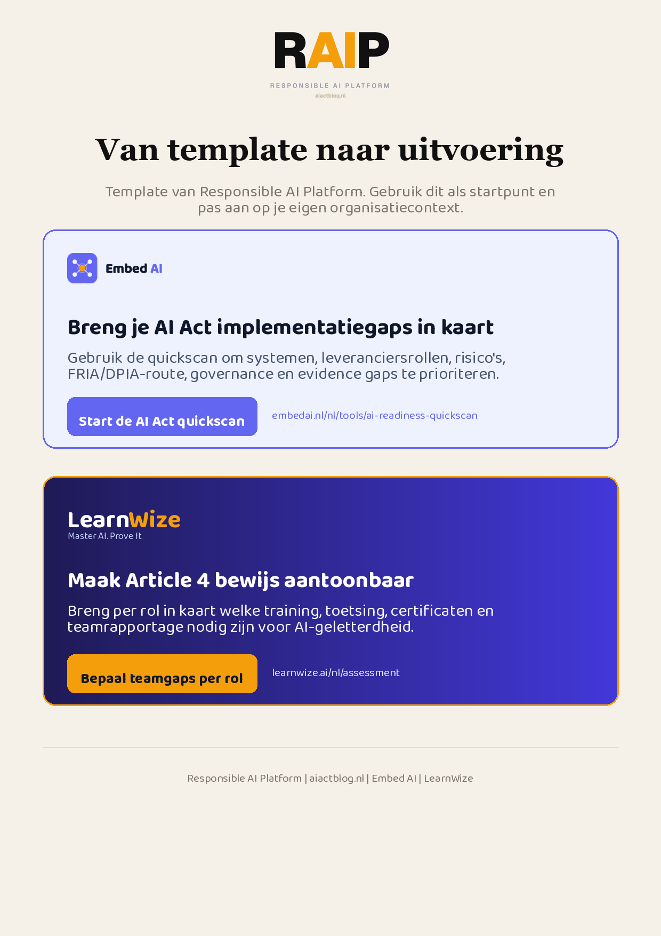
Klikbare links: Start de AI Act quickscan | Bepaal teamgaps per rol
AIACT_BRANDED_CTA_V2

