AI Governance
Framework
Organizational AI Governance Implementation Guide
EU AI Act Aligned

Version 1.0 | March 2026
Responsible AI Platform

1. Executive Summary
This framework establishes the governance structure, processes, and controls for responsible AI management within [Organization Name]. It aligns with the EU AI Act (Regulation 2024/1689) and integrates with existing governance mechanisms.
Organization Name:
________________________________________________________________________________
Industry/Sector:
________________________________________________________________________________
Framework Owner:
________________________________________________________________________________
Effective Date:
________________________________________________________________________________

2. Governance Principles

Accountability
Clear ownership and responsibility for all AI systems and their outcomes

Transparency
Openness about AI use, capabilities, and limitations to all stakeholders

Fairness
Prevention of bias and discrimination in AI systems and their outcomes

Safety
Prioritization of safety and security in AI development and deployment

Privacy
Protection of personal data and privacy rights in all AI operations

Human Agency
Meaningful human oversight and control over AI systems

Sustainability
Consideration of environmental and social impact of AI systems

3. Three Lines Model for AI
Line | Function | Responsibilities
1st Line: AI Operations | Business units, AI developers, deployers | Day-to-day AI operations; compliance with policies; risk identification; incident reporting
2nd Line: AI Risk & Compliance | AI Officer, Legal, DPO, Risk Management | Policy development; risk assessment oversight; compliance monitoring; training coordination
3rd Line: AI Assurance | Internal Audit, External Audit | Independent assurance; framework effectiveness; regulatory compliance verification

4. Governance Bodies

4.1 Board / Executive Level
Responsibility | Description
AI Strategy approval | Approve organizational AI strategy and risk appetite
Resource allocation | Ensure adequate budget and personnel for AI governance
Regulatory accountability | Ultimate accountability for EU AI Act compliance
Reporting | Receive quarterly AI governance reports

4.2 AI Governance Committee
Aspect | Details
Composition | AI Officer (chair), DPO, Legal, IT, HR, Business representatives
Meeting frequency | Monthly (minimum quarterly)
Decision authority | Approve/reject high-risk AI deployments, policy changes, incident responses
Reporting | Reports to Board/Executive quarterly

4.3 AI Officer
Responsibility | Description
Compliance coordination | Day-to-day EU AI Act compliance management
AI Register | Maintain and update the organizational AI register
Risk assessments | Coordinate risk classifications and FRIAs
Training | Oversee AI literacy program (Article 4)
Incident management | Lead AI incident response process
Regulatory liaison | Primary contact for regulators and market surveillance

5. Key Processes

5.1 AI System Approval Process
- Business case submission with intended purpose
- Risk classification (prohibited / high / limited / minimal)
- Impact assessment (FRIA for high-risk, DPIA for personal data)
- Technical review (architecture, data, security)
- AI Governance Committee decision
- Implementation with controls
- Post-deployment monitoring

5.2 Ongoing Monitoring
- Performance metrics review (monthly)
- Bias and fairness audits (quarterly)
- Compliance status update (quarterly)
- AI register review (quarterly)
- Regulatory landscape scan (quarterly)
- Stakeholder feedback review (ongoing)

5.3 Change Management
- Evaluate if change constitutes substantial modification (Art. 25)
- If substantial: new conformity assessment required
- Update technical documentation
- Update AI register
- Notify affected stakeholders
- Re-train oversight personnel if needed

6. Compliance Mapping
EU AI Act Requirement | Internal Process | Responsible | Evidence
Art. 4 - AI Literacy | Training program | HR + AI Officer | Training records
Art. 9 - Risk Management | AI approval process | AI Officer | Risk assessments
Art. 10 - Data Governance | Data management policy | DPO + IT | Data documentation
Art. 11 - Technical Documentation | Documentation standard | AI developers | Technical docs
Art. 12 - Record-keeping | Logging infrastructure | IT | System logs
Art. 13 - Transparency | Transparency notices | Legal + Product | User notices
Art. 14 - Human Oversight | Oversight procedures | Business owners | Oversight records
Art. 26 - Deployer obligations | Deployment checklist | AI Officer | Deployment records
Art. 27 - FRIA | FRIA process | AI Officer + Legal | FRIA documents
Art. 49 - Registration | AI Register | AI Officer | EU database entries
Art. 50 - Transparency | Disclosure templates | Legal + Product | Published notices
Art. 62 - Incident reporting | Incident response plan | AI Officer | Incident reports
Art. 72 - Post-market monitoring | Monitoring framework | AI Officer + IT | Monitoring reports

7. Maturity Assessment
Rate your organization's current maturity for each governance area:
Area | Level 1  Ad Hoc | Level 2  Defined | Level 3  Managed | Level 4  Optimized
AI Strategy & Vision | ☐ | ☐ | ☐ | ☐
Governance Structure | ☐ | ☐ | ☐ | ☐
Risk Management | ☐ | ☐ | ☐ | ☐
Compliance & Legal | ☐ | ☐ | ☐ | ☐
Data Governance | ☐ | ☐ | ☐ | ☐
AI Literacy & Training | ☐ | ☐ | ☐ | ☐
Incident Management | ☐ | ☐ | ☐ | ☐
Monitoring & Assurance | ☐ | ☐ | ☐ | ☐
Stakeholder Engagement | ☐ | ☐ | ☐ | ☐
Ethics & Responsible AI | ☐ | ☐ | ☐ | ☐

8. Implementation Roadmap
Phase | Timeline | Activities | Deliverables
Foundation | Month 1-2 | Appoint AI Officer, establish committee, inventory AI systems | AI Register v1, Governance charter
Policy | Month 2-3 | Develop policies, risk classification, approval process | AI Policy, Acceptable Use, Risk framework
Compliance | Month 3-5 | FRIA for high-risk systems, documentation, training program | FRIAs, Technical docs, Training curriculum
Operations | Month 5-6 | Launch monitoring, incident response, audit program | Dashboards, Incident plan, Audit schedule
Optimization | Ongoing | Continuous improvement, maturity advancement, regulatory updates | Quarterly reports, Updated policies

9. Document Control
Version | Date | Author | Changes
1.0 | [DD-MM-YYYY] | [Name] | Initial version

Template provided by Responsible AI Platform | www.aiactblog.nl

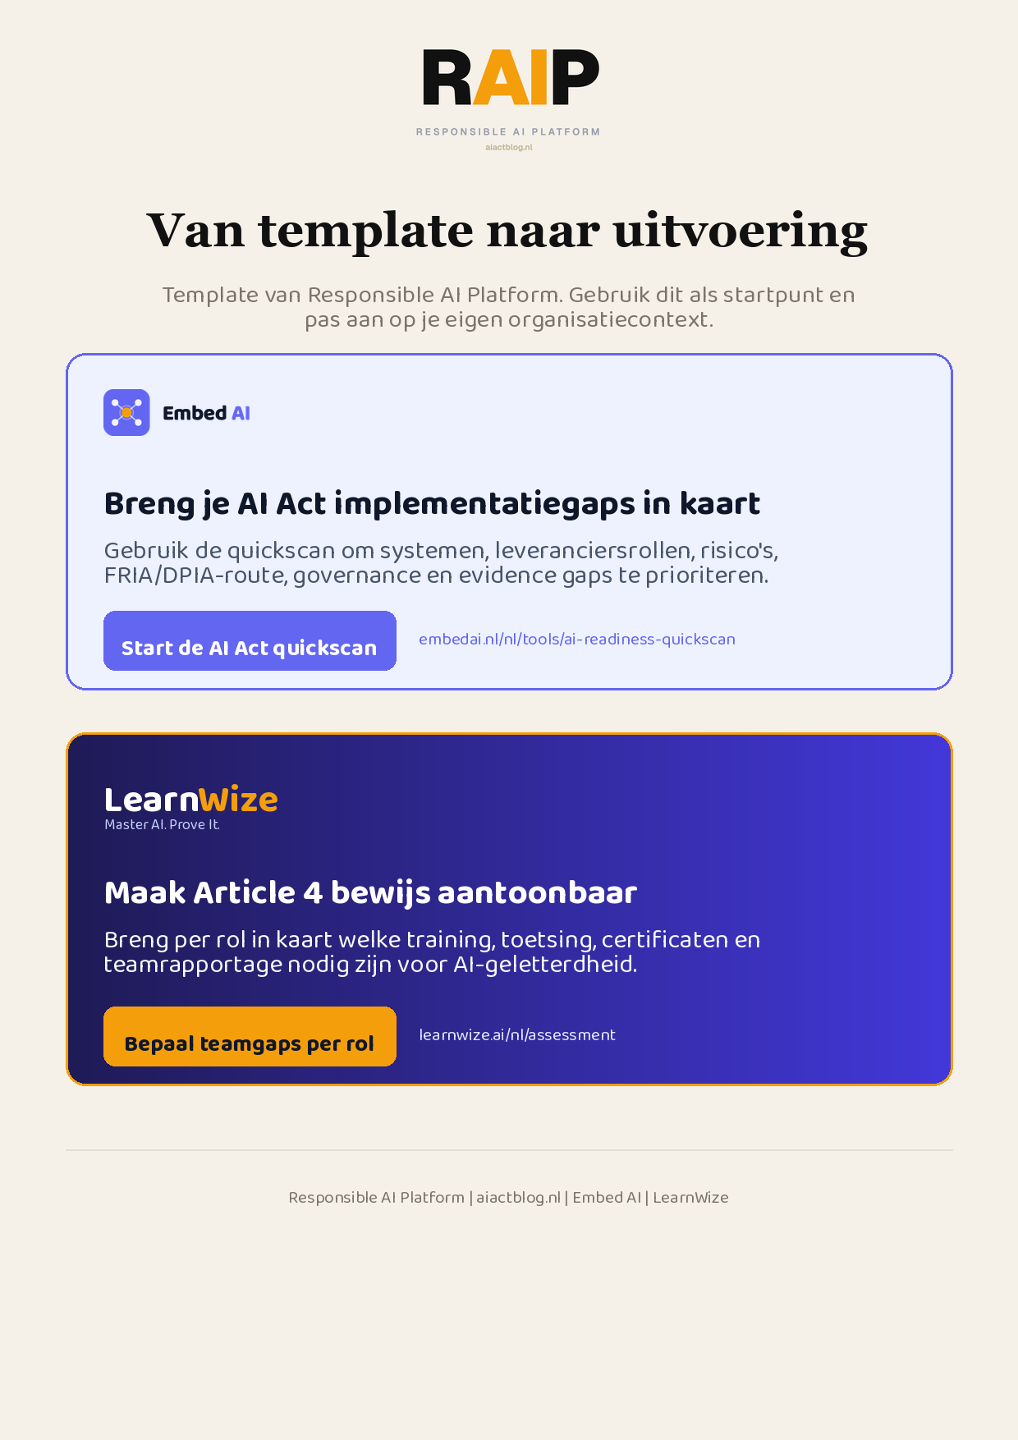
Klikbare links: Start de AI Act quickscan | Bepaal teamgaps per rol
AIACT_BRANDED_CTA_V2

