Acceptable AI
Use Policy
Employee Guidelines for Responsible AI Tool Usage
ChatGPT, Copilot, Gemini & Other AI Tools

Version 1.0 | March 2026
Responsible AI Platform

1. Purpose
This policy provides clear guidelines for all employees on the acceptable and responsible use of AI tools in the workplace. It covers both organization-provided AI tools and publicly available AI services (ChatGPT, Microsoft Copilot, Google Gemini, etc.).

2. General Principles
- AI tools are productivity aids, not replacements for professional judgment
- You remain accountable for all outputs you use or share, even if AI-generated
- Always verify AI-generated information before relying on it for decisions
- Never share confidential, personal, or proprietary information with public AI tools
- Be transparent about AI use: inform colleagues and clients when AI significantly contributed to work

3. Approved AI Tools
Tool | Approved Use | Data Classification Allowed | Approval Required
[Organization AI Platform] | All business tasks | Up to Confidential | No
Microsoft Copilot (Enterprise) | Office productivity, drafting, analysis | Up to Internal | No
ChatGPT (Team/Enterprise) | Research, brainstorming, drafting | Up to Internal | No
Public ChatGPT / Gemini / Claude | General research, non-sensitive tasks only | Public only | No
GitHub Copilot | Code assistance (approved repos only) | Up to Internal | IT approval
Custom / other AI tools | Case by case | Depends on assessment | AI Officer approval

4. Prohibited Uses
The following uses of AI tools are strictly prohibited:
✘ Entering personal data (names, emails, addresses, BSN numbers) into public AI tools
✘ Uploading confidential documents, contracts, or financial data to unauthorized AI services
✘ Using AI to make automated decisions about individuals without human review
✘ Generating misleading or deceptive content (deepfakes, fake reviews, impersonation)
✘ Using AI to circumvent security controls or access restrictions
✘ Submitting AI-generated work as original work in regulatory filings without disclosure
✘ Using AI for any purpose that violates applicable laws or company policies
✘ Entering client-specific information or trade secrets into any external AI tool

5. Data Classification Guide
Classification | Description | AI Tool Restriction
Public | Published information, marketing materials | Any approved AI tool
Internal | Internal communications, non-sensitive business data | Enterprise AI tools only
Confidential | Client data, financial reports, strategy documents | Organization AI platform only
Restricted | Personal data (GDPR), trade secrets, legal matters | No AI tools without explicit approval

6. Best Practices for AI Use

6.1 Before Using AI
☐ Classify the data you plan to input (see Section 5)
☐ Verify the AI tool is approved for that data classification
☐ Remove or anonymize personal data before inputting
☐ Consider whether AI is the right tool for this task

6.2 While Using AI
☐ Use clear, specific prompts to get better results
☐ Do not accept AI output at face value: verify facts, check sources
☐ Be aware of potential biases in AI responses
☐ Document significant AI-assisted decisions for traceability

6.3 After Using AI
☐ Review and edit AI-generated content before sharing
☐ Attribute AI contribution where required by team or client agreements
☐ Report any concerning, biased, or harmful AI outputs to your manager
☐ Delete sensitive conversation histories from AI tools after use

7. Reporting Concerns
If you encounter any of the following, report immediately to [AI Officer / IT Security]:
- AI tool producing harmful, biased, or discriminatory outputs
- Suspected data leak through an AI tool
- Colleague using AI tools in violation of this policy
- AI tool behaving unexpectedly or producing unreliable results
Report to:
________________________________________________________________________________
Email:
________________________________________________________________________________

8. Consequences of Violation
Violations of this policy may result in disciplinary action, ranging from a warning to termination, depending on severity. Serious violations involving personal data may also trigger GDPR reporting obligations.

9. Acknowledgment
By signing below, I confirm that I have read, understood, and agree to comply with this policy.
Employee Name:
________________________________________________________________________________
Signature:
________________________________________________________________________________
Date:
________________________________________________________________________________
Template provided by Responsible AI Platform | www.aiactblog.nl

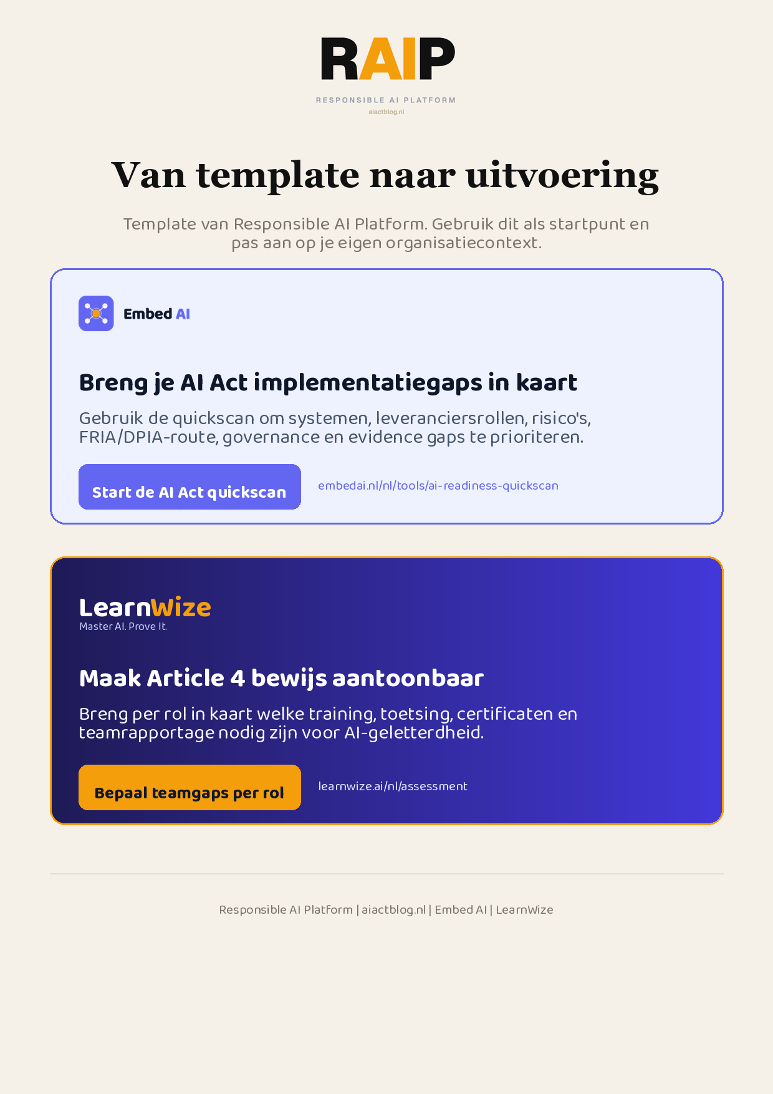
Klikbare links: Start de AI Act quickscan | Bepaal teamgaps per rol
AIACT_BRANDED_CTA_V2

